**Mini Project Documentation**

**GITAM COURSE REGISTRATION**

**BATCH 11**

**MANDA SATYA AKHIL- 122010322046**

**MANDA HARI HARAN- 122010322034**

**P.NIYATII-122010322047**



**A)Requirement Analysis/Abstract of the Project**

**1)The abstract of our project is to make the Design a database for the Course Registration.**

**2)** **Before the commencement of the new semester, GITAM students must register for courses.**

**3)** **Our college's offerings are all four-year degrees. Each course has a distinct designation, title, description, year, category, id, credits.**

**4)** **There may be few or many instructional and lab components in a course.**

**5)** **Each faculty member instructs just one course.**

**6)** **Each faculty member also includes an email address, name, department, room number and mobile number.**

**7)** **Every student has a special identification number(ID), name, and academic year, mobile number.**

**8)** **A course may feature a few or many course-specific instructional components (i.e. tutorial sections are not shared by different courses).**

**9)** **There might be one or multiple course-specific lab parts in a course (i.e. lab sections are not shared by different courses).**

**10)** **There are zero to many courses listed as the requirements for each course.**

**11)** **Only a student who has successfully completed all requirements may enrol for a course.**

**12)** **We maintain records of each student's past coursework and current course registrations in the system.**

**13)** **Only courses from the relevant year may be registered for by a student, therefore a student in year X of study may only register for and take courses from year X.**

**USE OF COURSE REGISTRATION:**

**GITAM students need to register for courses before the new semester start. All of the programs in our college take four years to finish. Once they finish a semester then they have to choose the courses which they are going to opt for the next semester and course registration helps in selecting the respective courses which a student is going to study next. we provide the details of the every faculty(name, id, contact_number, mail, building_no) where students can understand which faculty is going to teach the course. A student can register a course only if he/she has passed all the prerequisites. now we are going to create a database for the Course Registration where student can select the courses and get their time table. This is how course registration looks:**

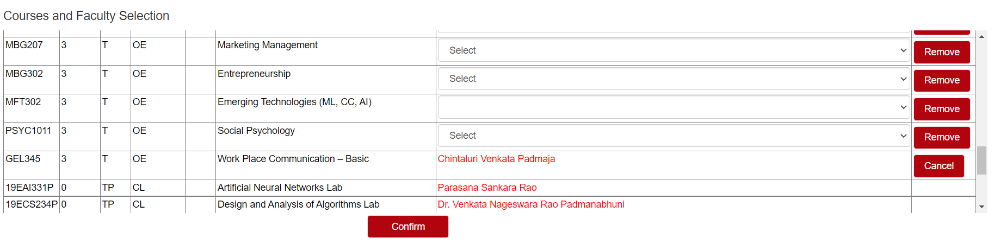

**After registration student will get a time table based on the courses he selected**

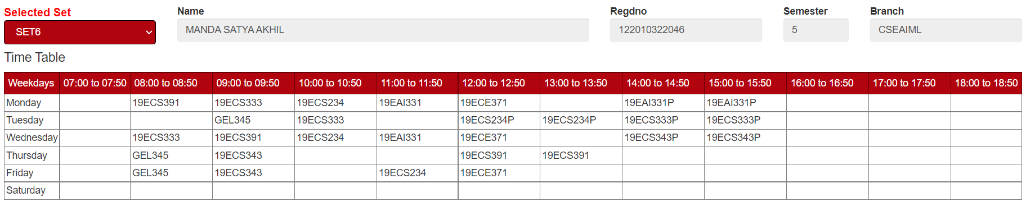

**We give each faculty member's information (name, ID, contact information, mailing address, and building number) so that students may determine which faculty member will be teaching the course.**

**Now, a database for course registration will be built, allowing students to choose their courses and view their schedules.**

**REQUIREMENT ANALYSIS:**

***ENTITIES:***

**STUDENTS**

**COURSES**

**FACULTY**

**COURSEREGISTER**

**FACULTYREGISTER**

***ATTRIBUTES:***

**STUDENTS : ID, NAME, EMAIL, MOBILE_NUMBER, PASSWORD, CLASSROOM.**

**COURSE: NAME, ID, TYPE, CREDITS, CATEGORY, TUTORIAL SESSIONS, LAB SESSIONS.**

**FACULTY: ID, NAME, DEPARTMENT, ROOM_NO, CONTACT_NO, EMAIL_ADDRESS, PASSWORD.**

**COURSEREGISTER: registration id, course1, course2, course3(list of courses).**

**FACULTYREGISTER: faculty id, faculty courses1, faculty course2(list of faculty).**

***RELATIONS:***

**students register to courses.**

**Faculty teaches course.**

**Students selects faculty.**

**Students chooses courseregister.**

**course have tutorial sections.**

**Facultyregister opts courses which they teach.**

**course have labsections.**

**course is taught by faculty.**

**taught by will be having descriptive attributes.**

**lab has faculty who is teaching the theory will be assigned.**

**course has prerequisites.**

**courses are either Pass or Fail.**

**Students register to course only if passed all the prerequisites.**

**ER diagram**

**An Entity Relation Diagram is a type of flowchart that illustrates how the “entities” relate to each other within a system**

**One can understand the glimpse of project by having a look into the ER diagram as it diagrammatically explain the project to the viewer**

**ER DIAGRAM OF COURSE REGISTRATION:**

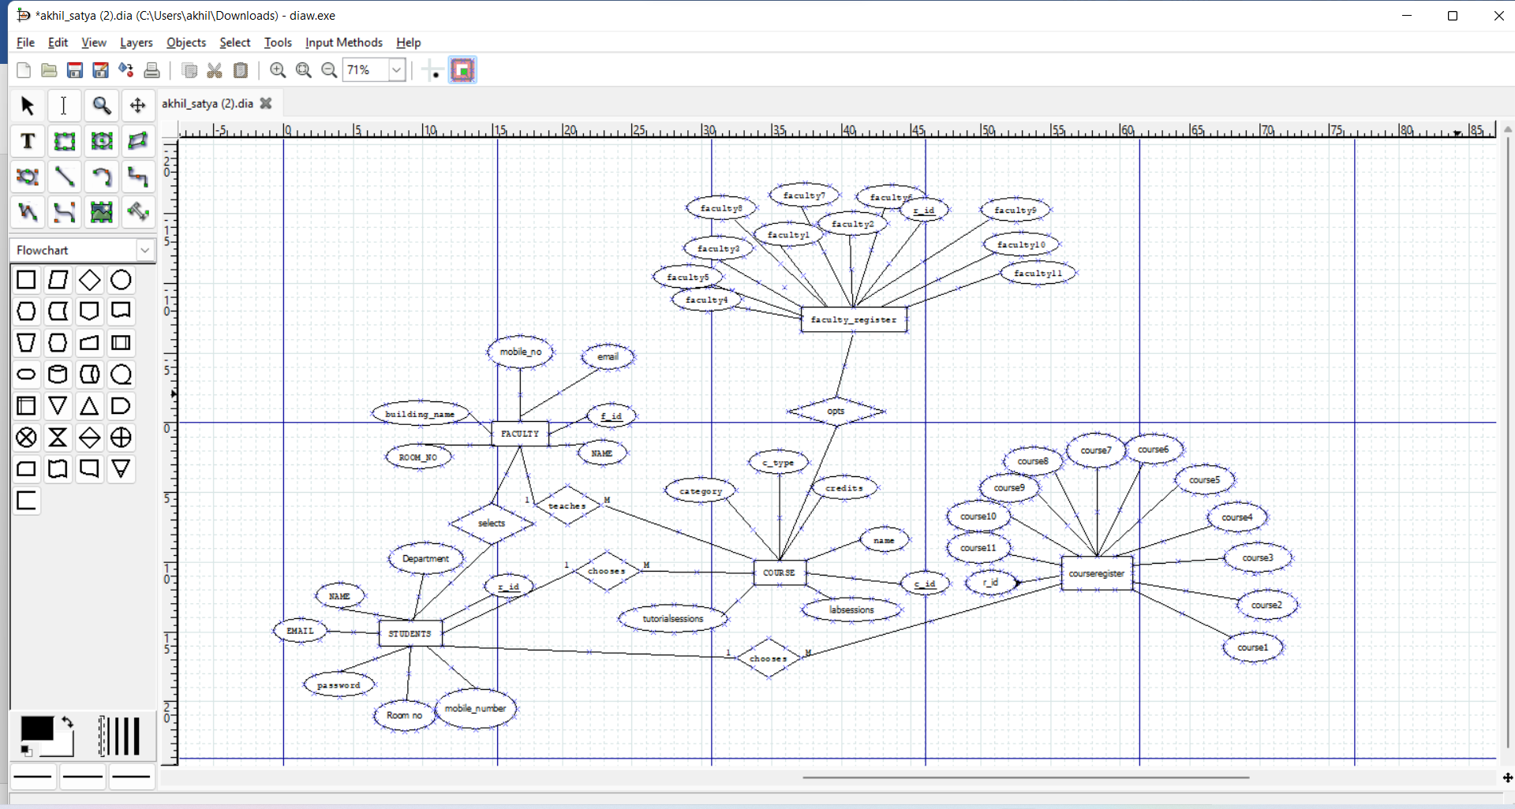

**Logical Database Design**

**Logical database design is the process of transforming (or mapping) a conceptual schema of the application domain into a schema for the data model underlying a particular DBMS, such as the relational or object-oriented data model.**

**Student table**

**SQL command to create student table:**

**create table students(name varchar(20), email varchar(20), department varchar(20), sid int(20), room_no varchar(20), mobile_no int(20), passsword varchar(20));**

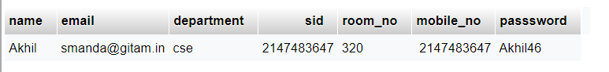

**Faculty table**

**SQL command to create faculty table:**

**create table Faculty(name varchar(20), f_id varchar(20), email varchar(20), mobile_no int(20), building_name varchar(20),room_no varchar(20));**

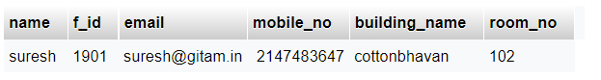

**Course table**

**SQL command to create Course table:**

**create table course(name varchar(20), c_id varchar(20), credits int(20), c_type varchar(20), category varchar(20), tutorialsessions int(20), labsessions int(20));**



**Courseregister table**

**SQL command to create Courseregister table:**

**create table courseregister(sid int(20), course1 varchar(20), course2 varchar(20), course3 varchar(20), course4 varchar(20), course5 varchar(20), course6 varchar(20), course7 varchar(20), course8 varchar(20), course9 varchar(20), course10 varchar(20), course11 varchar(20), FOREIGN KEY (sid) REFERENCES students (sid));**



**Facultyregister table**

**SQL command to create Facultyregister table:**

**create table Facultyregister(cid int(20), Faculty1 varchar(20) , Faculty2 varchar(20) , Faculty3 varchar(20) , Faculty5 varchar(20) , Faculty6 varchar(20) , Faculty7 varchar(20) , Faculty8 varchar(20) , Faculty9 varchar(20) , Faculty10 varchar(20) , Faculty11 varchar(20) , FOREIGN KEY (cid) REFERENCES course(cid));**

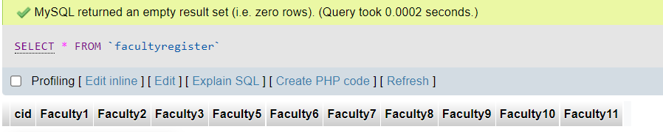

**DATABASE CONNECTIVITY**

* **A database connection is a facility in computer science that allows client software to talk to database server software, whether on same machine or not**
* **A connection is required to insert and retrieve data into and from database through webpage**
* **Connection to database is possible through any of the programming languages/scripting languages such as java, python, etc.**
* **ODBC (Open Data Base Connectivity) is standard database access method developed by the SQL access group in 1992**
* **Languages such as java use JDBC, python use modules such as flask_mysqldb that translate generalized database calls into vendor specific calls**
* **Upon successful connection one can interact with the database through the host system or from the any other system.**

**To understand what Flask is you have to understand a few general terms:**

* **WSGI Web Server Gateway Interface (WSGI) has been adopted as a standard for Python web application development. WSGI is a specification for a universal interface between the web server and the web applications.**
* **Werkzeug It is a WSGI toolkit, which implements requests, response objects, and other utility functions. This enables building a web framework on top of it. The Flask framework uses Werkzeug as one of its bases.**
* **jinja2 is a popular templating engine for Python. A web templating system combines a template with a certain data source to render dynamic web pages.**

**CODE:**

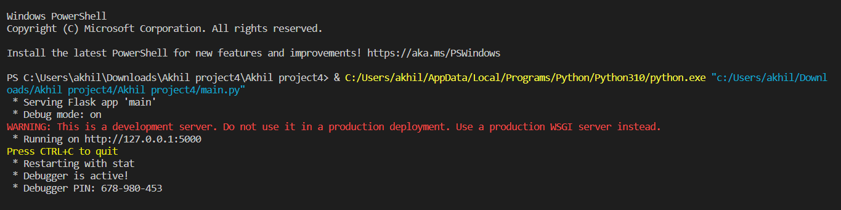

**FRONTEND OF OUR PROJECT: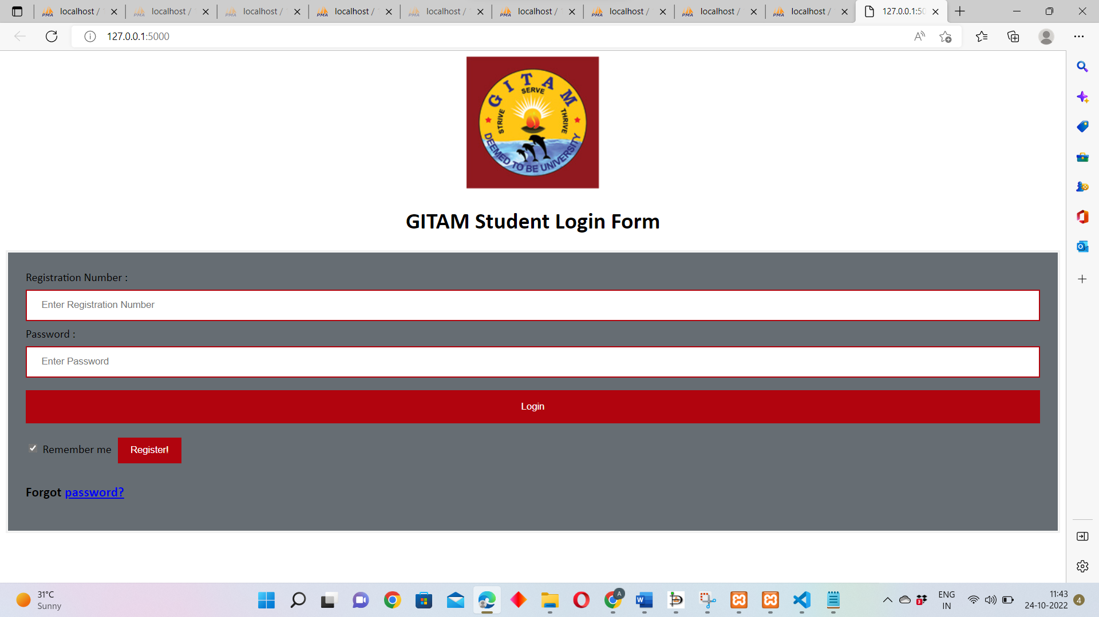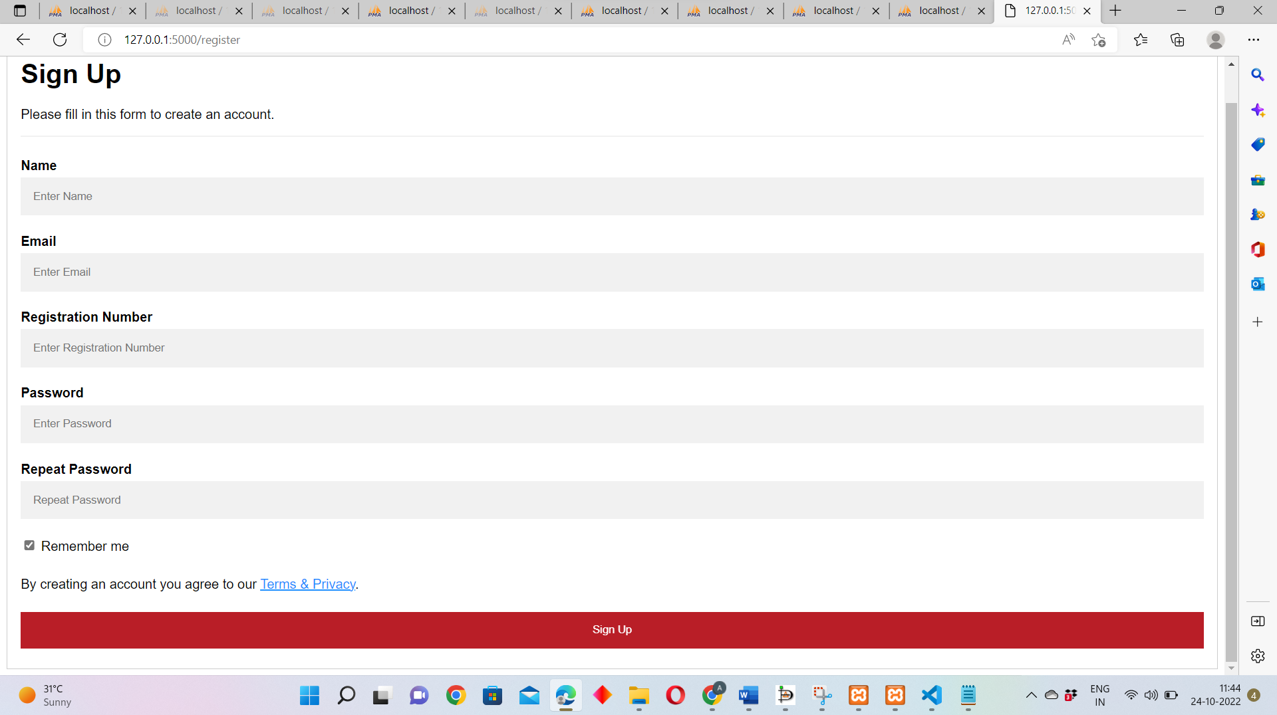**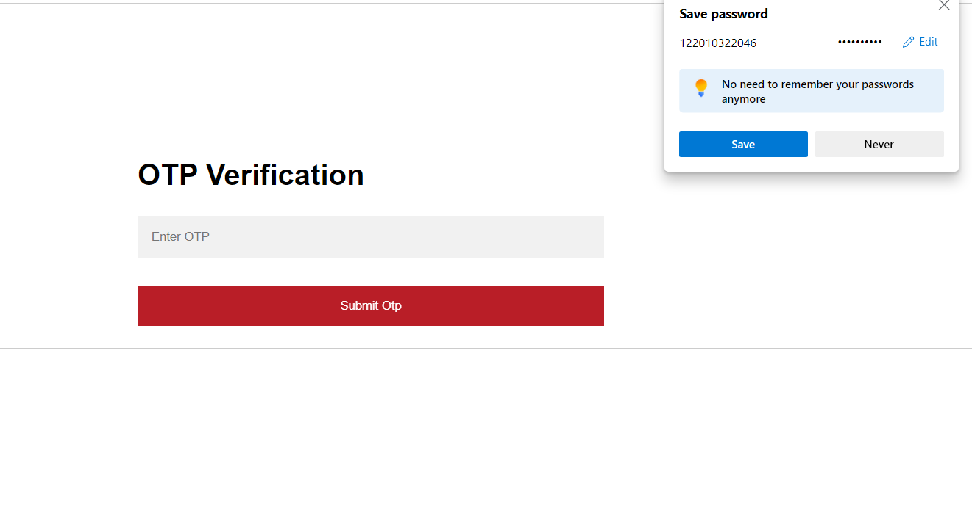

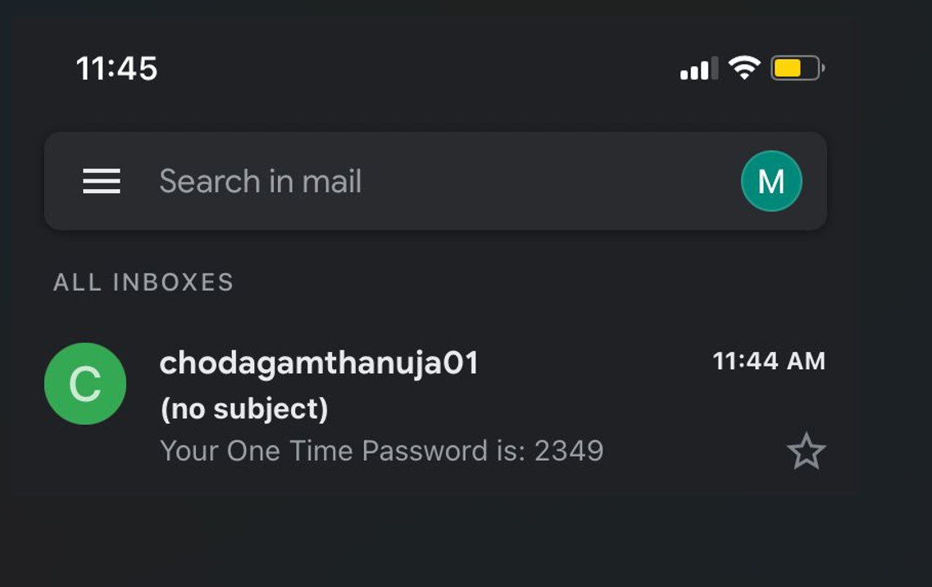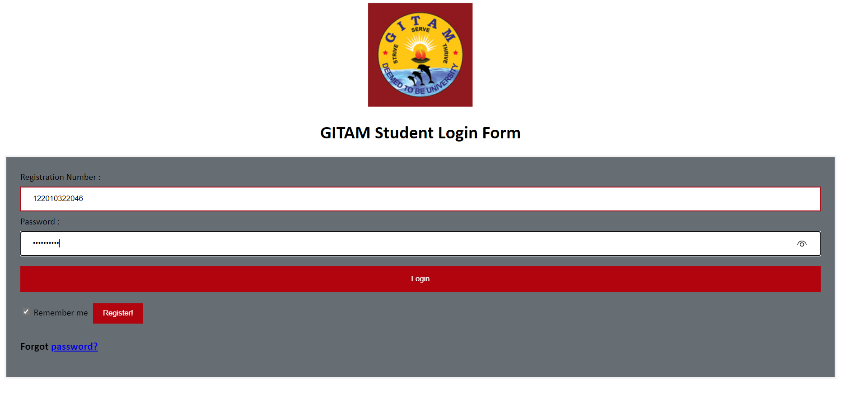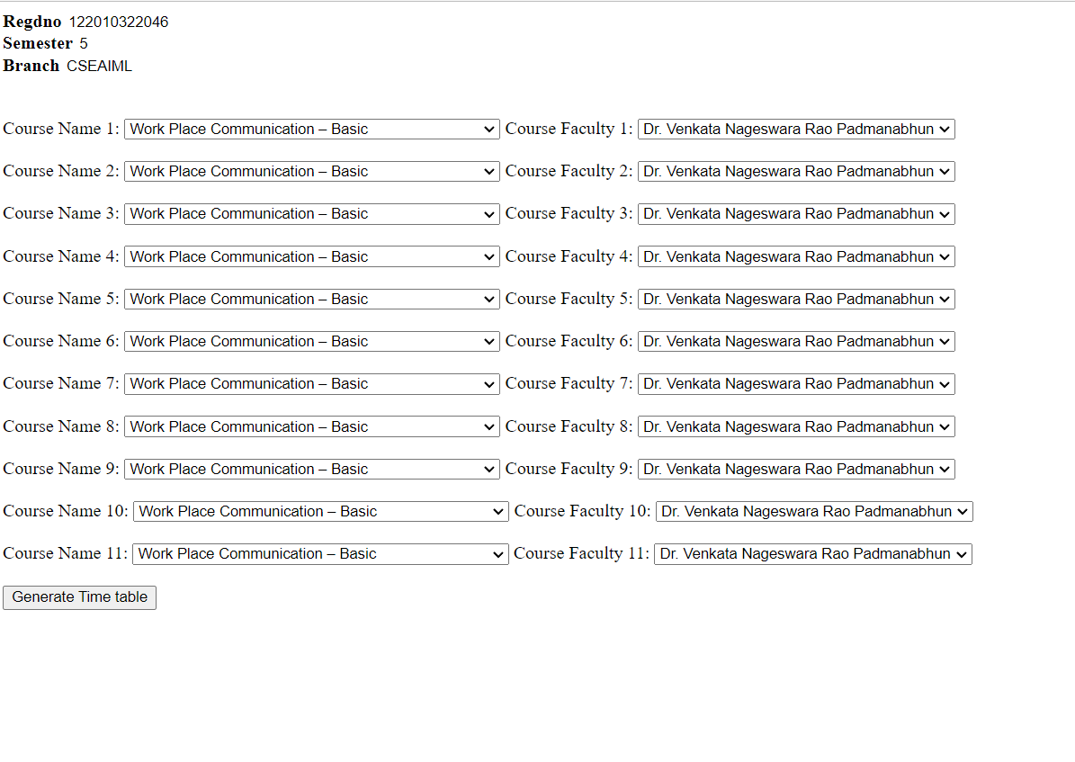

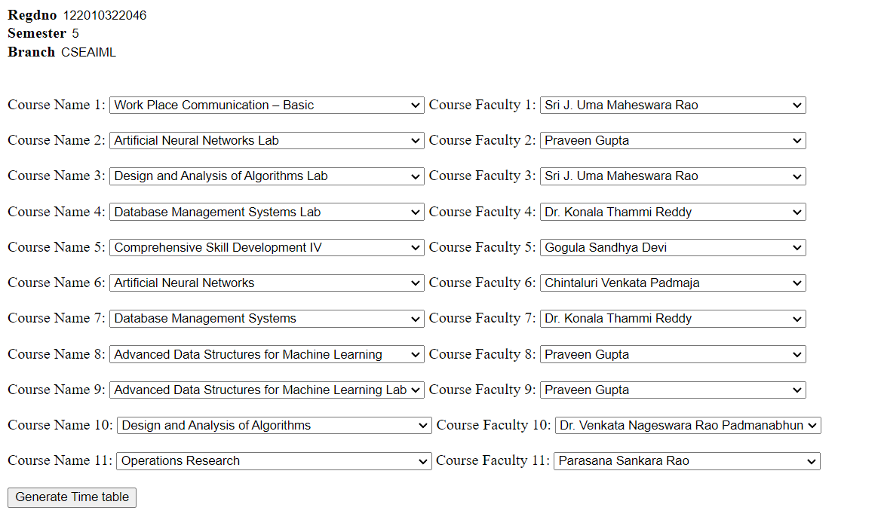 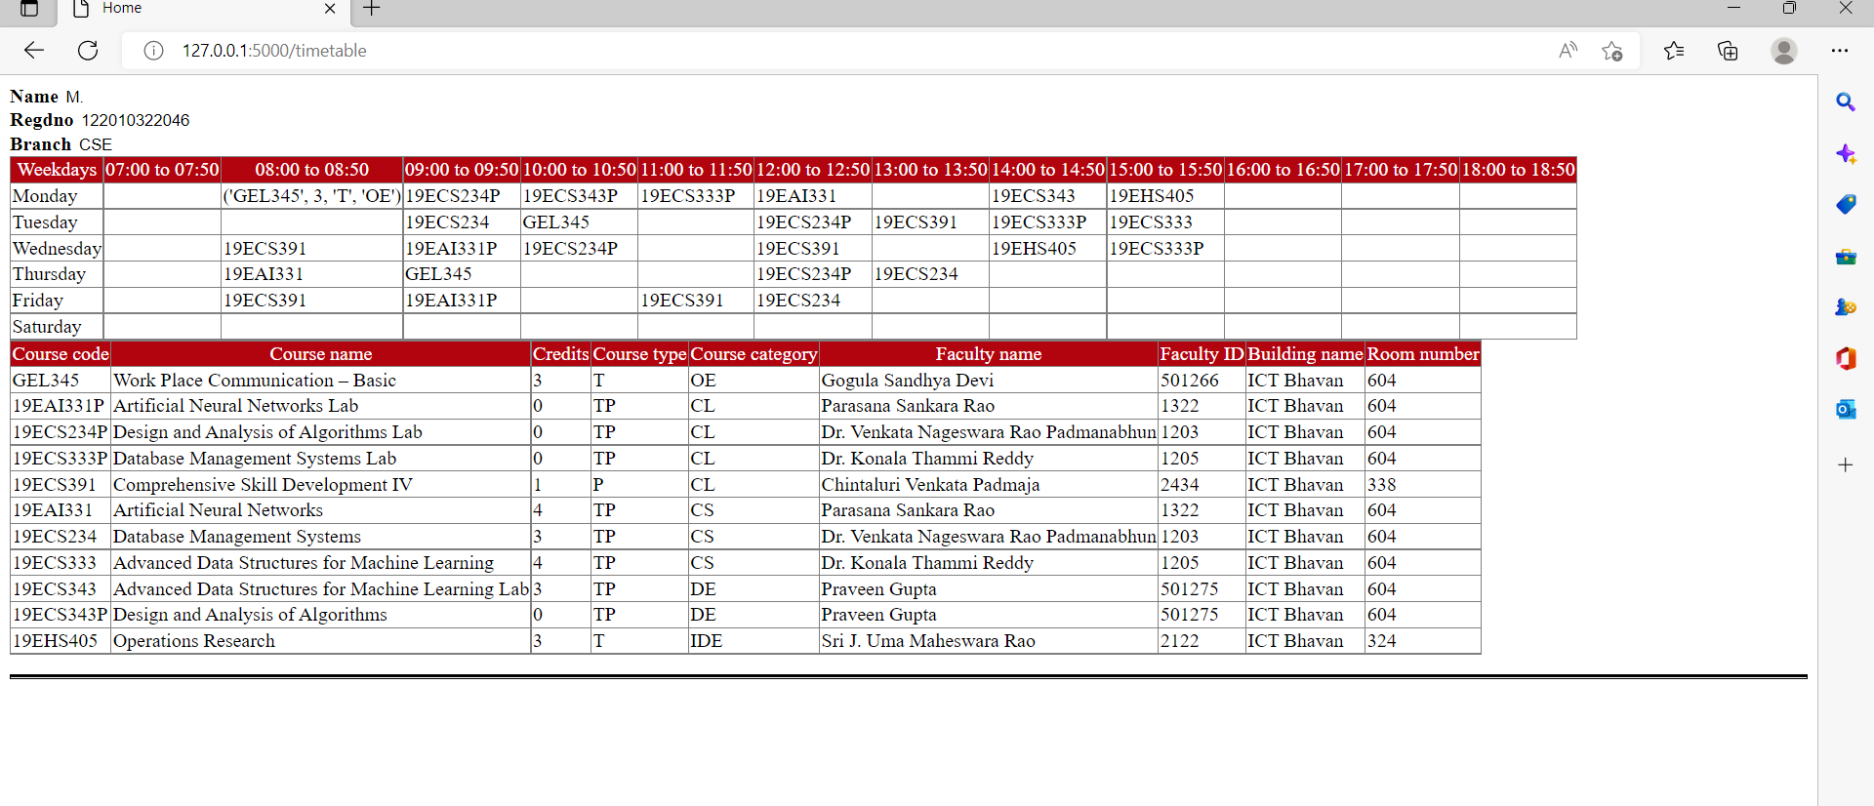

**Take away’s**

* **Understood the need of Database and Database Management Systems in Real world**
* **Implemented front-end technologies such as HTML, CSS,**
* **Implemented Back-end technology (Flask) to interact with database**
* **Improved Relevant skills such as team work and concentration**